

1. **Driver Sleep Detection System**

ELBC803- Embedded Design Project

By

* Mohammad Baher 88599
* Hussien Rida 89073
* Mohammad Jawad Rmeity

Submitted to the Faculty of Engineering of the

Islamic University in Lebanon

Wardeneih, Lebanon

in partial fulfillment of the requirements for the degree of

**BACHELOR OF ENGINEERING IN COMPUTER AND COMMUNICATIONS**

**Spring 2024-2025**

**Approved by:**

 **Dr. Samer Shantaf**

TABLE OF CONTENTS

CHAPTER 1 INTRODUCTION 1

CHAPTER 2 System Design and Implementation 3

2.1 Introduction 3

2.2 Required Components 3

2.3 Circuit Design 4

2.4 Implementation Steps 5

CHAPTER 3 Conclusion and Future Work 8

3.1 Conclusion 8

3.2 Future Work 8

LIST OF FIGURES

Figure ‎2‑1 Complete circuit 5

Figure ‎2‑2 Circuit 5

Figure ‎2‑3 Led connections 6

Figure ‎2‑4 Connecting Arduino to breadboard 6

# CHAPTER 1 INTRODUCTION

### ****1.1 What is Engineering?****

Engineering is the application of scientific and mathematical principles to design, develop, and innovate structures, machines, systems, and processes that improve the quality of life and solve real-world problems. It plays a fundamental role in modern society by providing technological solutions to challenges across various domains. Engineering is a vast and multidisciplinary field, and it encompasses several key branches

* 1. **Project Idea: Driver Sleep Detection System**

The aim of this project is to develop a Driver Sleep Detection System that enhances road safety by monitoring the driver's alertness level. Drowsy driving is one of the leading causes of traffic accidents worldwide, especially during long trips or night driving. Many accidents occur because drivers fall asleep behind the wheel without realizing how tired they are.

This system is designed to detect signs of drowsiness or sleep in drivers, using sensors to monitor physical indicators such as eye movement or head position. Once drowsiness is detected, the system triggers an alert—such as a buzzer or vibration—to wake the driver and prevent potential accidents.

By implementing this system, we aim to:

* Reduce road accidents caused by driver fatigue.
* Improve overall road safety.
* Raise awareness of the dangers of drowsy driving.
* Provide a low-cost solution that can be integrated into vehicles.
  1. **What is Arduino and What is it Used For?**

Arduino is an open-source electronics platform based on easy-to-use hardware and software. It consists of a microcontroller (such as the Arduino Uno) that can be programmed to interact with sensors, actuators, and other electronic components.

Arduino is widely used in both educational and industrial projects due to its flexibility, affordability, and large community support. It is ideal for prototyping and developing embedded systems such as home automation, robotics, health monitors, and interactive gadgets.

In this project, Arduino acts as the core controller of the sleep detection system. It processes data from sensors (e.g., an IR sensor or a camera module for eye detection) and makes real-time decisions—such as activating an alarm if the driver shows signs of sleep. Its simplicity allows for fast development and testing of the system.

# System Design and Implementation

## Introduction

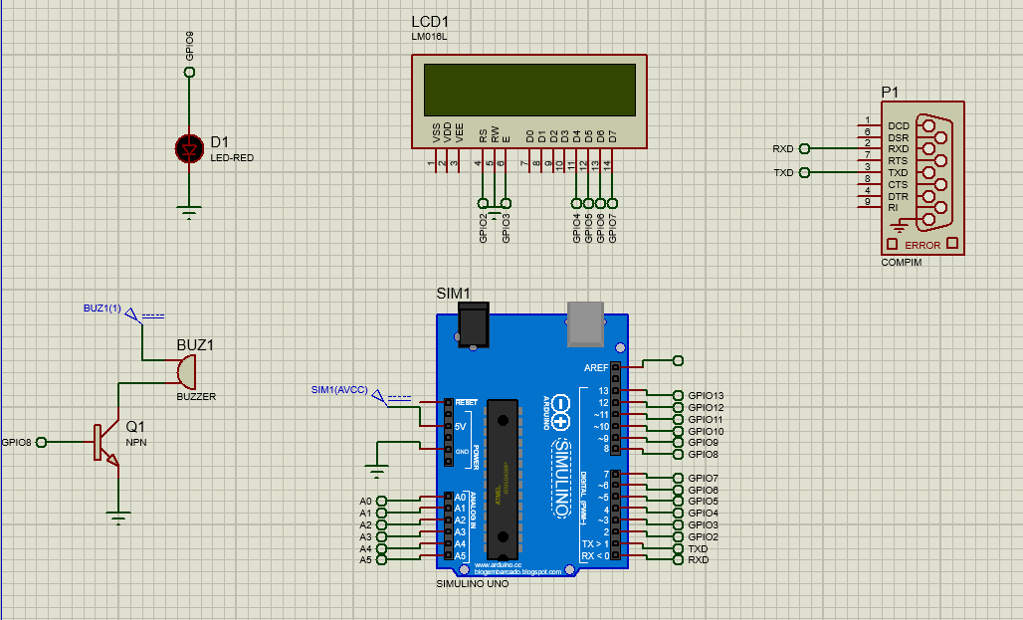

**1. Arduino UNO (SIMULINO UNO) – Center of the circuit**

* **Function:** Main microcontroller that reads data from sensors and controls outputs like the buzzer, LED, and LCD.
* **Pins Used:** GPIO0–13 (Digital I/Os), A0–A5 (Analog I/Os), 5V and GND for power.

**2. LCD1 (LM016L) – Top Center**

* **Function:** Displays system messages like “Driver Awake”, “Driver Drowsy”, or alerts.
* **Pins:**
  + VSS, VDD: Power (GND and +5V)
  + VEE: Contrast control
  + RS, RW, E: Control lines
  + D0–D7: Data lines for text display (in 8-bit mode)
* **Connected to:** Several GPIO pins of Arduino (GPIO0–7 in this diagram)

**3. BUZ1 (Buzzer) – Bottom Left**

* **Function:** Makes sound to alert the driver when drowsiness is detected.
* **Connected to:** A transistor (Q1) used as a switch, which is controlled by GPIO8.

**4. Q1 (NPN Transistor) – Bottom Left**

* **Function:** Acts as a switch to control high current to the buzzer.
* **Base connected to GPIO8:** When GPIO8 is HIGH, the transistor conducts and activates the buzzer.

**5. D1 (LED-RED) – Top Left**

* **Function:** Visual indicator (e.g., turns ON when drowsiness is detected).
* **Connected to:** GPIO8 (same as buzzer control – could be to indicate alarm status).

**6. SIM1 (Power Header) – Left of Arduino**

* **Function:** Connected to Arduino 5V and GND for powering the system.
* **May be linked to external modules like sensors or simulation components.**

**7. P1 (COMPIM/Serial Port) – Top Right**

* **Function:** Represents a virtual serial port used in Proteus for serial communication (e.g., for debugging or PC interface).
* **Pins:**
  + TXD and RXD: Transmit and receive data
  + May be used to monitor system messages on a PC serial monitor

**8. GPIO Pins (on Arduino UNO) – Right side of Arduino**

* **GPIO8:** Controls both the LED (D1) and the transistor for the buzzer (Q1).
* **GPIO0–7:** Connected to the LCD for data and control.
* **Others (GPIO9–13):** Currently unused but available for other sensors (e.g., IR sensor, eye blink sensor).

## Required Components

|  |  |
| --- | --- |
|  | ARDUINO UNO R3 x1  The main brain for the system. |
|  | Breadboard x1  For the connection and components |
|  | 16*2 LCD x1  To display a message for driver |
|  | RGB LED x2  To indicate the color corresponding to each case |
|  | Buzzer x1  To Make sound to alert the driver |

## Circuit Design

In Figure ‎2‑1, we show …

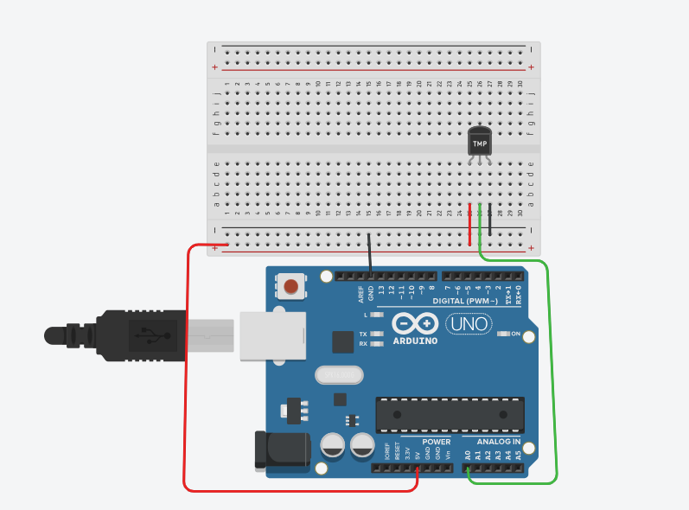

Figure ‎2‑1 Circuit

## Implementation Steps

Here, you need to explain how did you implemented your project **with figures explaining the different steps.**

* Step 1

We connect the led to the pin … as shown in

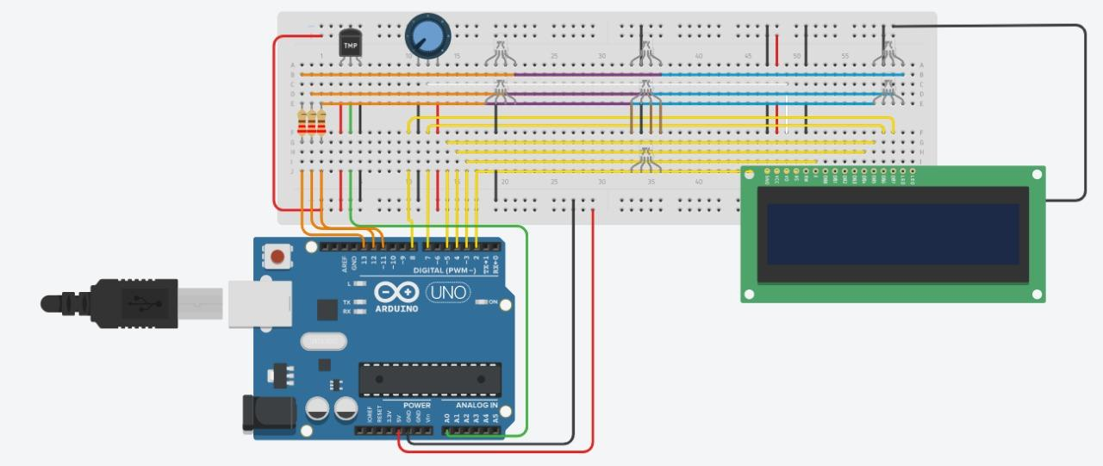

Figure ‎2‑2 Led connections

An example of a figure is shown in Figure 2.2. Pay attention how this figure has a caption under it. This is done by right clicking on your figure and then choosing “insert a caption”.

The list of figures in page III is dynamic. You need to right click on it and update it when you finish inserting all your figures and captions so it is updated with the final figures in your report.

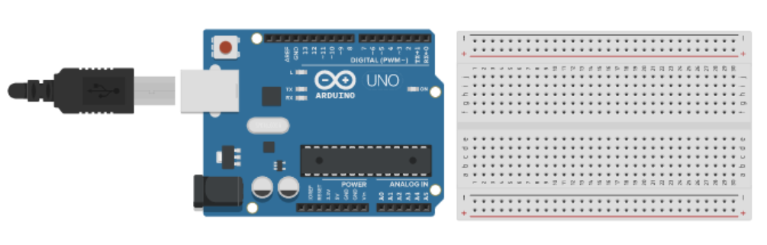

Figure ‎2‑3 Connecting Arduino to breadboard

# Conclusion and Future Work

## Conclusion

In this paragraph, you write a summary of what you presented in the above two chapters. Instead of using expressions like “in our project we will implement ….”, in the conclusion we usually use expressions like “As we could see above, in our project we implemented ……”.

Besides, you need to write about the experiences you learned while taking the course and implementing the project.

## Future Work

In this paragraph, you need to write any idea you have about expanding the work you did in your project to be more developed and to be used in real life.